

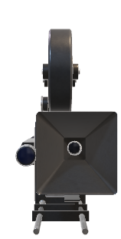

**CINEBOOK**

**PODAR INTERNATIONAL SCHOOL**

Submitted by: Mahip Thakore

Sparsh Bhargava

Class: 12TH A-1

Submitted to: Mr. Mitul Bhatt

PGT(CS)

**MOVIE BOOKING SYSTEM**

COMPUTER SCIENCE PROJECT

2025-2026

INDEX

|  |
| --- |
| Certificate |
| Acknowledgement |
| Hardware & Software |
| Introduction |
| Python Source Code |
| MySQL Database |
| Output |
| Bibliography |

HARDWARE

&  
SOFTWARE

HARDWARE:

1. Lenovo LOQ
2. Desktop

SOFTWARE:

1. Windows 11
2. MySQL
3. Python IDLE



INTRODUCTION

CineBook is a comprehensive **desktop-based movie ticket booking application** built with Python and Tkinter for the graphical user interface. This robust system provides an end-to-end solution for movie theatres to manage their movie listings, showtimes, seat bookings, and customer ticketing operations.

**Key Features**

**🎬 Movie Management**

* **Dual-section catalogue**: "Now Showing" and "Upcoming" movies
* **Detailed movie information**: Title, description, ratings, tags, release dates, and poster images
* **Admin panel** for adding, editing, and removing movies
* **Automatic poster management** with file copying and organization

**🎫 Ticket Booking System**

* **Interactive seat selection** with real-time availability
* **Multiple showtimes** throughout the day (10:00 AM to 10:00 PM)
* **8 auditorium support** with customizable seating layouts
* **Date-specific booking** with calendar integration

**💾 Database Architecture**

* **MySQL backend** with relational data modelling
* **Four main tables**: Movies, Shows, Seats, and Bookings
* **Referential integrity** with proper foreign key constraints
* **Automated database setup** and sample data seeding

**🎨 User Experience**

* **Modern dark-themed UI** with intuitive navigation
* **Scrollable movie grids** with high-quality poster displays
* **Rotating advertisement banners** for promotions
* **Responsive design** with smooth interactions

**📱 Admin Capabilities**

* **Complete CRUD operations** for movie management
* **Poster image handling** with automatic file organization
* **Section management** (Now Showing vs Upcoming)
* **Release date scheduling** and movie categorization

**🎟️ Digital Ticketing**

* **QR code integration** for quick verification
* **Professional ticket generation** with booking details
* **Save-to-PNG functionality** for digital tickets
* **Booking confirmation** with seat numbers and show details

**Technical Stack**

* **Frontend**: Tkinter (Python's standard GUI toolkit)
* **Backend**: MySQL with mysql-connector-python
* **Image Processing**: Pillow (PIL) for image handling
* **QR Generation**: qrcode library
* **Date Management**: tkcalendar for date pickers
* **File Management**: Built-in OS and in-build modules

**System Requirements**

* **Python 3.7+** with required packages
* **MySQL Server** (local or remote)
* **Minimum 2GB RAM**
* **Windows/Linux/macOS** compatible

**Target Users**

1. **Movie Theatres** - For managing their daily operations
2. **Cinema Chains** - Multi-auditorium support
3. **Event Managers** - For special screenings and premieres
4. **Customers** - Easy ticket booking experience

**Business Benefits**

* **Streamlined operations** with automated booking processes
* **Reduced manual errors** through digital seat management
* **Enhanced customer experience** with visual seat selection
* **Increased revenue** through efficient seat utilization
* **Marketing opportunities** via promotional ad banners

**Future Enhancements**

The modular architecture allows for easy integration of additional features such as:

* Online payment gateway integration
* Mobile app companion
* Loyalty programs and discounts
* Advanced analytics and reporting
* Multi-language support
* Social media sharing capabilities

CineBook represents a modern approach to cinema management, combining robust backend functionality with an elegant user interface to deliver a seamless movie booking experience for both theatre operators and moviegoers.

PYTHON SOURCE CODE

# main.py

import os

import shutil

import mysql.connector

from mysql.connector import errorcode

import tkinter as tk

from tkinter import ttk, messagebox, filedialog, Toplevel, Canvas

from tkcalendar import Calendar

from PIL import Image, ImageTk, ImageDraw, ImageFont

import qrcode

from datetime import datetime, date

# ---------------- CONFIG (Update your MySQL credentials here) ----------------

DB_CONFIG = {

"host": "localhost",

"user": "root",

"password": "Hawk_Mahip0", # <-- change

"database": "cinebook_db"

}

# -----------------------------------------------------------------------------

# ---------------- PATHS ----------------

BASE_DIR = os.path.dirname(os.path.abspath(__file__))

POSTERS_DIR = os.path.join(BASE_DIR, "posters")

ADS_DIR = os.path.join(BASE_DIR, "ads")

os.makedirs(POSTERS_DIR, exist_ok=True)

os.makedirs(ADS_DIR, exist_ok=True)

# ---------------- SAFE IMAGE LOADER ----------------

def load_image_safe(rel_path, size):

"""Load image relative to BASE_DIR; return ImageTk.PhotoImage or None."""

full = os.path.join(BASE_DIR, rel_path)

if not os.path.exists(full):

print(f"[load_image_safe] Missing: {full}")

return None

try:

img = Image.open(full).convert("RGBA")

img = img.resize(size, Image.LANCZOS)

return ImageTk.PhotoImage(img)

except Exception as e:

print("Error loading image:", full, e)

return None

# ---------------- PLACEHOLDER ADS ----------------

def ensure_ads_placeholders():

files = os.listdir(ADS_DIR)

if len([f for f in files if f.lower().endswith((".png",".jpg",".jpeg"))]) == 0:

for i in range(1,4):

path = os.path.join(ADS_DIR, f"ad{i}.png")

if not os.path.exists(path):

img = Image.new("RGB", (980,140), (40+i*30, 70+i*10, 100+i*5))

d = ImageDraw.Draw(img)

fnt = ImageFont.load_default()

d.text((20,60), f"Place your ad in /ads/ad{i}.png", fill="white", font=fnt)

img.save(path)

# ---------------- MYSQL SETUP ----------------

def ensure_database_and_tables():

# create database if not present

try:

cnx = mysql.connector.connect(host=DB_CONFIG["host"], user=DB_CONFIG["user"], password=DB_CONFIG["password"])

cur = cnx.cursor()

cur.execute(f"CREATE DATABASE IF NOT EXISTS {DB_CONFIG['database']}")

cur.close()

cnx.close()

except mysql.connector.Error as e:

messagebox.showerror("Database error", f"Could not ensure database: {e}")

raise

# create tables

try:

cnx = mysql.connector.connect(**DB_CONFIG)

cur = cnx.cursor()

cur.execute("""

CREATE TABLE IF NOT EXISTS movies (

id INT AUTO_INCREMENT PRIMARY KEY,

title VARCHAR(255),

description TEXT,

rating VARCHAR(20),

tags VARCHAR(255),

poster_path VARCHAR(255),

section ENUM('Now Showing','Upcoming'),

release_date DATE

) ENGINE=InnoDB;

""")

cur.execute("""

CREATE TABLE IF NOT EXISTS shows (

id INT AUTO_INCREMENT PRIMARY KEY,

movie_id INT,

show_date DATE,

show_time TIME,

audi INT,

FOREIGN KEY (movie_id) REFERENCES movies(id) ON DELETE CASCADE

) ENGINE=InnoDB;

""")

cur.execute("""

CREATE TABLE IF NOT EXISTS seats (

id INT AUTO_INCREMENT PRIMARY KEY,

show_id INT,

seat_no VARCHAR(10),

is_booked TINYINT(1) DEFAULT 0,

FOREIGN KEY (show_id) REFERENCES shows(id) ON DELETE CASCADE

) ENGINE=InnoDB;

""")

cur.execute("""

CREATE TABLE IF NOT EXISTS bookings (

id INT AUTO_INCREMENT PRIMARY KEY,

show_id INT,

seat_no VARCHAR(10),

customer_name VARCHAR(255),

booked_on DATETIME DEFAULT CURRENT_TIMESTAMP,

FOREIGN KEY (show_id) REFERENCES shows(id) ON DELETE CASCADE

) ENGINE=InnoDB;

""")

cnx.commit()

cur.close()

cnx.close()

except mysql.connector.Error as e:

messagebox.showerror("Database error", f"MySQL error: {e}")

raise

# ---------------- SEED SAMPLE MOVIES (FORCE UPDATE) ----------------

def seed_sample_movies():

cnx = mysql.connector.connect(**DB_CONFIG)

cur = cnx.cursor()

# CLEAR EXISTING DATA

cur.execute("DELETE FROM bookings")

cur.execute("DELETE FROM seats")

cur.execute("DELETE FROM shows")

cur.execute("DELETE FROM movies")

sample = [

# Now Showing (Jan–May)

("Interstellar", "A team travels through a wormhole to find a new home for humanity.", "95%", "IMAX, Dolby Atmos", os.path.join("posters","interstellar.png"), "Now Showing", "2026-01-15"),

("Oppenheimer", "The story of J. Robert Oppenheimer.", "93%", "IMAX, Dolby Vision", os.path.join("posters","oppenheimer.png"), "Now Showing", "2026-02-12"),

("KGF", "Rise of a man from poverty to power.", "88%", "Dolby", os.path.join("posters","kgf.png"), "Now Showing", "2026-03-05"),

("Fast X", "High-octane car action.", "75%", "IMAX", os.path.join("posters","fast_x.png"), "Now Showing", "2026-03-22"),

("Ford v Ferrari", "Racing rivalry drama.", "89%", "Dolby", os.path.join("posters","ford_v_ferrari.png"), "Now Showing", "2026-04-02"),

("Avatar: Way of Water", "Return to Pandora.", "90%", "IMAX, Dolby Vision", os.path.join("posters","avatar_way_of_water.png"), "Now Showing", "2026-04-20"),

("Hangover", "Comedy of errors.", "80%", "Dolby", os.path.join("posters","hangover.png"), "Now Showing", "2026-05-06"),

("Ratatouille", "A rat dreams of being a chef.", "92%", "Dolby 7.1", os.path.join("posters","ratatouille.png"), "Now Showing", "2026-05-18"),

("Dishoom", "Action-cop movie.", "74%", "Dolby", os.path.join("posters","dishoom.png"), "Now Showing", "2026-05-26"),

("John Wick 4", "Assassin saga continues.", "91%", "Dolby Atmos", os.path.join("posters","johnwick4.png"), "Now Showing", "2026-05-28"),

# Upcoming (Jun–Dec) - CHANGES MADE HERE

("Kung Fu Panda", "Po returns for more adventure.", "N/A", "Dolby Atmos", os.path.join("posters","kung_fu_panda.png"), "Upcoming", "2026-06-10"),

("Tron Legacy", "Sam's journey in cyberworld.", "N/A", "IMAX", os.path.join("posters","tron_legacy.png"), "Upcoming", "2026-07-01"), # MOVED FROM SEPT 25

("Aladdin", "A street rat finds a magic lamp.", "N/A", "Dolby Vision", os.path.join("posters","aladdin.png"), "Upcoming", "2026-07-20"),

("Cruella", "Origin story of Cruella.", "N/A", "Dolby Vision", os.path.join("posters","cruella.png"), "Upcoming", "2026-08-05"),

("Hobbit", "An epic fantasy journey of Bilbo Baggins.", "N/A", "Dolby", os.path.join("posters","hobbit.png"), "Upcoming", "2026-08-25"), # CHANGED FROM LORD OF THE RINGS

("Alien Covenant", "Horror sci-fi returns.", "N/A", "IMAX", os.path.join("posters","alien_covenant.png"), "Upcoming", "2026-09-10"),

("Inglorious Bastards", "Jewish soldiers to commit violent acts of retribution against the Nazis.", "N/A", "Dolby 7.1", os.path.join("posters","inglorious_bastards.png"), "Upcoming", "2026-09-25"), # MOVED FROM JULY 1

("Avatar : Fire And Ash", "Pandora saga continues.", "N/A", "IMAX", os.path.join("posters","avatar3.png"), "Upcoming", "2026-10-10"),

]

insert_q = """INSERT INTO movies (title, description, rating, tags, poster_path, section, release_date)

VALUES (%s,%s,%s,%s,%s,%s,%s)"""

cur.executemany(insert_q, sample)

cnx.commit()

cur.close()

cnx.close()

print("Database updated with new movie list!")

# ---------------- ADMIN: copy poster/ad into folder and return path ----------------

def admin_copy_file_to_folder(src_path, folder):

if not os.path.exists(src_path):

return None

os.makedirs(folder, exist_ok=True)

fname = os.path.basename(src_path)

dst = os.path.join(folder, fname)

# if filename already exists, add suffix

base, ext = os.path.splitext(fname)

count = 1

while os.path.exists(dst):

dst = os.path.join(folder, f"{base}_{count}{ext}")

count += 1

shutil.copyfile(src_path, dst)

# return relative path from BASE_DIR

return os.path.relpath(dst, BASE_DIR)

# ---------------- QR + Receipt generator ----------------

def generate_ticket_image(movie_title, date_str, time_str, audi, seats, booking_id):

# build an image showing the info + a QR code

w, h = 800, 500

img = Image.new("RGB", (w, h), (20,20,20))

d = ImageDraw.Draw(img)

font_title = ImageFont.load_default()

try:

font_title = ImageFont.truetype("arial.ttf", 28)

font_sub = ImageFont.truetype("arial.ttf", 16)

except:

font_title = ImageFont.load_default()

font_sub = ImageFont.load_default()

d.text((30,30), f"CineBook Ticket #{booking_id}", fill="white", font=font_title)

d.text((30,80), f"Movie: {movie_title}", fill="white", font=font_sub)

d.text((30,110), f"Date: {date_str} Time: {time_str}", fill="white", font=font_sub)

d.text((30,140), f"Audi: {audi} Seats: {', '.join(seats)}", fill="white", font=font_sub)

# QR payload: basic text

qr_payload = f"{movie_title}|{date_str}|{time_str}|{audi}|{','.join(seats)}|ID:{booking_id}"

qr = qrcode.make(qr_payload)

qr = qr.resize((200,200))

img.paste(qr, (w-240, 60))

return img

# ---------------- GUI App ----------------

class CineBookApp:

def __init__(self, root):

self.root = root

root.title("CineBook — Movie Ticket Booking")

root.geometry("1200x760")

root.configure(bg="#0f0f10")

ensure_ads_placeholders()

# ad images

self.ad_images = []

self.ad_index = 0

self.load_ads()

# top bar with Admin

top = tk.Frame(root, bg="#0f0f10")

top.pack(fill="x", padx=16, pady=10)

tk.Label(top, text="CineBook", font=("Helvetica", 26, "bold"), fg="white", bg="#0f0f10").pack(side="left")

tk.Button(top, text="Admin", command=self.open_admin_panel, bg="#333", fg="white").pack(side="right")

# ad banner

self.ad_label = tk.Label(root, bg="#0f0f10")

self.ad_label.pack(pady=(0,12))

self.rotate_ads() # starts rotation via after()

# main content (scrollable)

content = tk.Frame(root, bg="#0f0f10")

content.pack(fill="both", expand=True, padx=12, pady=(0,18))

self.canvas = Canvas(content, bg="#0f0f10", highlightthickness=0)

vbar = ttk.Scrollbar(content, orient="vertical", command=self.canvas.yview)

self.canvas.configure(yscrollcommand=vbar.set)

self.canvas.pack(side="left", fill="both", expand=True)

vbar.pack(side="right", fill="y")

self.inner = tk.Frame(self.canvas, bg="#0f0f10")

self.canvas.create_window((0,0), window=self.inner, anchor="nw")

self.inner.bind("<Configure>", lambda e: self.canvas.configure(scrollregion=self.canvas.bbox("all")))

self.canvas.bind_all("<MouseWheel>", self._on_mousewheel)

# sections

self.build_sections()

# ---------------- ads ----------------

def load_ads(self):

files = [f for f in os.listdir(ADS_DIR) if f.lower().endswith((".png",".jpg",".jpeg"))]

for f in files:

rel = os.path.join("ads", f)

img = load_image_safe(rel, (980,140))

if img:

self.ad_images.append(img)

def rotate_ads(self):

if self.ad_images:

img = self.ad_images[self.ad_index % len(self.ad_images)]

self.ad_label.config(image=img)

self.ad_label.image = img

self.ad_index += 1

else:

# show a simple text if no ads

self.ad_label.config(text="Place ad images in /ads/", fg="white", bg="#0f0f10", font=("Arial", 14))

self.root.after(4000, self.rotate_ads)

def _on_mousewheel(self, event):

self.canvas.yview_scroll(int(-1*(event.delta/120)), "units")

# ---------------- content build ----------------

def build_sections(self):

# Now Showing

tk.Label(self.inner, text="NOW SHOWING", font=("Helvetica", 18, "bold"), fg="#ffffff", bg="#0f0f10").pack(anchor="w", pady=(6,8))

self.populate_movie_grid("Now Showing")

tk.Label(self.inner, text="UPCOMING", font=("Helvetica", 18, "bold"), fg="#ffffff", bg="#0f0f10").pack(anchor="w", pady=(18,8))

self.populate_movie_grid("Upcoming")

def populate_movie_grid(self, section):

grid = tk.Frame(self.inner, bg="#0f0f10")

grid.pack(padx=8, pady=6, fill="x")

cnx = mysql.connector.connect(**DB_CONFIG)

cur = cnx.cursor()

cur.execute("SELECT id, title, description, rating, tags, poster_path, section, release_date FROM movies WHERE section=%s", (section,))

rows = cur.fetchall()

cur.close()

cnx.close()

cols = 4

for i, row in enumerate(rows):

mid, title, desc, rating, tags, poster_path, sect, rdate = row

card = tk.Frame(grid, bg="#141414", bd=0)

card.grid(row=i//cols, column=i%cols, padx=12, pady=12, sticky="n")

poster_img = load_image_safe(poster_path, (160,240))

if poster_img is None:

# create simple fallback image

img = Image.new("RGB", (160,240), (30,30,30))

d = ImageDraw.Draw(img)

f = ImageFont.load_default()

d.text((18,110), "No Poster", fill="white", font=f)

poster_img = ImageTk.PhotoImage(img)

btn = tk.Button(card, image=poster_img, text=title, compound="top", fg="white", bg="#141414", bd=0,

command=lambda m_id=mid: self.open_movie_window(m_id))

btn.image = poster_img

btn.pack()

tk.Label(card, text=title, fg="white", bg="#141414", font=("Helvetica", 11, "bold")).pack(pady=(6,0))

tk.Label(card, text=f"RT: {rating}", fg="#bdbdbd", bg="#141414").pack()

tk.Label(card, text=tags, fg="#9aa0a6", bg="#141414", wraplength=160).pack(pady=(4,8))

# ---------------- movie detail window ----------------

def open_movie_window(self, movie_id):

cnx = mysql.connector.connect(**DB_CONFIG)

cur = cnx.cursor()

cur.execute("SELECT id, title, description, rating, tags, poster_path, section, release_date FROM movies WHERE id=%s", (movie_id,))

row = cur.fetchone()

cur.close()

cnx.close()

if not row:

messagebox.showerror("Error", "Movie not found")

return

mid, title, desc, rating, tags, poster_path, section, rdate = row

win = Toplevel(self.root)

win.title(title)

win.geometry("900x620")

win.configure(bg="#0d0d0d")

left = tk.Frame(win, bg="#0d0d0d")

left.pack(side="left", padx=18, pady=18)

right = tk.Frame(win, bg="#0d0d0d")

right.pack(side="right", fill="both", expand=True, padx=18, pady=18)

poster_img = load_image_safe(poster_path, (320,480))

if poster_img:

p_lbl = tk.Label(left, image=poster_img, bg="#0d0d0d")

p_lbl.image = poster_img

p_lbl.pack()

else:

tk.Label(left, text="No Poster", fg="white", bg="#0d0d0d").pack()

tk.Label(right, text=title, font=("Helvetica", 22, "bold"), fg="white", bg="#0d0d0d").pack(anchor="nw")

tk.Label(right, text=desc or "No description", fg="#ccc", bg="#0d0d0d", wraplength=420, justify="left").pack(anchor="nw", pady=(8,12))

tk.Label(right, text=f"Rating (RT): {rating}", fg="#eee", bg="#0d0d0d").pack(anchor="nw", pady=2)

tk.Label(right, text=f"Tags: {tags}", fg="#eee", bg="#0d0d0d").pack(anchor="nw", pady=2)

tk.Label(right, text=f"Release: {rdate}", fg="#eee", bg="#0d0d0d").pack(anchor="nw", pady=2)

# date picker

tk.Label(right, text="Choose Date:", fg="white", bg="#0d0d0d").pack(anchor="nw", pady=(16,2))

date_var = tk.StringVar(value="Select date")

tk.Button(right, textvariable=date_var, width=20, bg="#1f6feb", fg="white",

command=lambda: open_calendar_popup(win, section, lambda d: date_var.set(d))).pack(anchor="nw")

# time picker

tk.Label(right, text="Choose Time:", fg="white", bg="#0d0d0d").pack(anchor="nw", pady=(12,2))

times = ["10:00:00", "13:30:00", "16:00:00", "19:30:00", "22:00:00"]

time_var = tk.StringVar(value=times[0])

ttk.Combobox(right, textvariable=time_var, values=times, width=18).pack(anchor="nw")

# audi

tk.Label(right, text="Audi:", fg="white", bg="#0d0d0d").pack(anchor="nw", pady=(12,2))

audi_var = tk.StringVar(value="1")

ttk.Combobox(right, textvariable=audi_var, values=[str(i) for i in range(1,9)], width=18).pack(anchor="nw")

# button seat selection

tk.Button(right, text="Open Seats", bg="#ff4b4b", fg="white", width=20,

command=lambda: open_seat_window(movie_id, title, section, date_var.get(), time_var.get(), audi_var.get())).pack(anchor="nw", pady=18)

# ---------------- ADMIN PANEL ----------------

def open_admin_panel(self):

win = Toplevel(self.root)

win.title("Admin Panel")

win.geometry("700x520")

win.configure(bg="#121212")

# left: movie list

left = tk.Frame(win, bg="#121212", width=300)

left.pack(side="left", fill="y", padx=10, pady=10)

right = tk.Frame(win, bg="#121212")

right.pack(side="right", fill="both", expand=True, padx=10, pady=10)

tk.Label(left, text="Movies (editable)", fg="white", bg="#121212", font=("Helvetica", 12, "bold")).pack(anchor="nw")

listbox = tk.Listbox(left, width=36, height=24)

listbox.pack(pady=8)

cnx = mysql.connector.connect(**DB_CONFIG)

cur = cnx.cursor()

cur.execute("SELECT id, title FROM movies")

rows = cur.fetchall()

for r in rows:

listbox.insert("end", f"{r[0]}: {r[1]}")

cur.close()

cnx.close()

# right: edit fields

tk.Label(right, text="Edit / Add Movie", fg="white", bg="#121212", font=("Helvetica", 12, "bold")).pack(anchor="nw")

f_title = tk.Entry(right, width=48)

f_title.pack(pady=6)

f_desc = tk.Text(right, height=6, width=48)

f_desc.pack(pady=6)

f_rating = tk.Entry(right, width=20)

f_rating.pack(pady=6)

f_tags = tk.Entry(right, width=48)

f_tags.pack(pady=6)

f_section = ttk.Combobox(right, values=["Now Showing", "Upcoming"], width=20)

f_section.pack(pady=6)

f_release = tk.Entry(right, width=20)

f_release.pack(pady=6)

poster_path_var = tk.StringVar(value="")

def choose_poster():

p = filedialog.askopenfilename(title="Select Poster Image", filetypes=[("Images","*.png;*.jpg;*.jpeg")])

if p:

rel = admin_copy_file_to_folder(p, POSTERS_DIR)

poster_path_var.set(rel)

messagebox.showinfo("Poster added", f"Poster copied to {rel}")

tk.Button(right, text="Choose Poster (copy)", command=choose_poster, bg="#2c7be5", fg="white").pack(pady=4)

tk.Label(right, textvariable=poster_path_var, fg="white", bg="#121212").pack()

def on_list_select(evt):

sel = listbox.curselection()

if not sel: return

text = listbox.get(sel[0])

mid = int(text.split(":")[0])

cnx = mysql.connector.connect(**DB_CONFIG)

cur = cnx.cursor()

cur.execute("SELECT title, description, rating, tags, poster_path, section, release_date FROM movies WHERE id=%s", (mid,))

r = cur.fetchone()

cur.close(); cnx.close()

if r:

f_title.delete(0,"end"); f_title.insert(0,r[0])

f_desc.delete("1.0","end"); f_desc.insert("1.0", r[1] or "")

f_rating.delete(0,"end"); f_rating.insert(0,r[2] or "")

f_tags.delete(0,"end"); f_tags.insert(0,r[3] or "")

poster_path_var.set(r[4] or "")

f_section.set(r[5] or "Now Showing")

f_release.delete(0,"end"); f_release.insert(0, r[6] or "")

listbox.bind("<<ListboxSelect>>", on_list_select)

def save_movie():

title = f_title.get().strip()

desc = f_desc.get("1.0","end").strip()

rating = f_rating.get().strip()

tags = f_tags.get().strip()

poster_rel = poster_path_var.get().strip()

section = f_section.get().strip()

release = f_release.get().strip() or None

if not title:

messagebox.showwarning("Missing", "Title required")

return

sel = listbox.curselection()

cnx = mysql.connector.connect(**DB_CONFIG)

cur = cnx.cursor()

if sel:

mid = int(listbox.get(sel[0]).split(":")[0])

cur.execute("""UPDATE movies SET title=%s, description=%s, rating=%s, tags=%s, poster_path=%s, section=%s, release_date=%s WHERE id=%s""",

(title, desc, rating, tags, poster_rel, section, release, mid))

messagebox.showinfo("Saved", "Movie updated")

else:

cur.execute("""INSERT INTO movies (title, description, rating, tags, poster_path, section, release_date) VALUES (%s,%s,%s,%s,%s,%s,%s)""",

(title, desc, rating, tags, poster_rel, section, release))

messagebox.showinfo("Saved", "Movie added")

cnx.commit()

cur.close()

cnx.close()

win.destroy()

# refresh main UI

self.refresh_main()

def delete_movie():

sel = listbox.curselection()

if not sel:

messagebox.showwarning("Select", "Select a movie to delete")

return

mid = int(listbox.get(sel[0]).split(":")[0])

if messagebox.askyesno("Confirm", "Delete movie and all its shows/bookings?"):

cnx = mysql.connector.connect(**DB_CONFIG)

cur = cnx.cursor()

cur.execute("DELETE FROM movies WHERE id=%s", (mid,))

cnx.commit()

cur.close(); cnx.close()

win.destroy()

self.refresh_main()

btn_frame = tk.Frame(right, bg="#121212")

btn_frame.pack(pady=10)

tk.Button(btn_frame, text="Save", command=save_movie, bg="#2ecc71", fg="white").pack(side="left", padx=6)

tk.Button(btn_frame, text="Delete", command=delete_movie, bg="#ff4b4b", fg="white").pack(side="left", padx=6)

tk.Button(btn_frame, text="Close", command=win.destroy, bg="#888", fg="white").pack(side="left", padx=6)

def refresh_main(self):

# simply redraw the inner area

for w in self.inner.winfo_children():

w.destroy()

self.build_sections()

# ---------------- calendar popup (section-aware) ----------------

def open_calendar_popup(parent, section, on_select):

cal_win = Toplevel(parent)

cal_win.title("Select Date")

cal_win.geometry("360x360")

if section == "Now Showing":

mind = date(2026,1,1); maxd = date(2026,5,31)

else:

mind = date(2026,6,1); maxd = date(2026,12,31)

cal = Calendar(cal_win, selectmode='day', year=mind.year, month=mind.month, day=mind.day,

mindate=mind, maxdate=maxd, date_pattern='yyyy-mm-dd')

cal.pack(pady=16)

def confirm():

on_select(cal.get_date())

cal_win.destroy()

tk.Button(cal_win, text="Confirm", command=confirm, bg="#2c7be5", fg="white").pack(pady=10)

# ---------------- seat window, bookings, receipts ----------------

def open_seat_window(movie_id, title, section, chosen_date, chosen_time, audi):

if not chosen_date or chosen_date == "Select date":

messagebox.showwarning("No date", "Please select a date first.")

return

# create/find show & seats

cnx = mysql.connector.connect(**DB_CONFIG)

cur = cnx.cursor()

cur.execute("SELECT id FROM shows WHERE movie_id=%s AND show_date=%s AND show_time=%s AND audi=%s", (movie_id, chosen_date, chosen_time, int(audi)))

r = cur.fetchone()

if r:

show_id = r[0]

else:

cur.execute("INSERT INTO shows (movie_id, show_date, show_time, audi) VALUES (%s,%s,%s,%s)", (movie_id, chosen_date, chosen_time, int(audi)))

cnx.commit()

show_id = cur.lastrowid

for i in range(1,21):

cur.execute("INSERT INTO seats (show_id, seat_no, is_booked) VALUES (%s,%s,%s)", (show_id, f"S{i:02}", 0))

cnx.commit()

cur.execute("SELECT seat_no, is_booked FROM seats WHERE show_id=%s ORDER BY id", (show_id,))

seat_rows = cur.fetchall()

cur.close(); cnx.close()

# UI for seats

win = Toplevel()

win.title(f"Seats — {title}")

win.geometry("720x560")

win.configure(bg="#0f0f0f")

tk.Label(win, text=f"{title}", font=("Helvetica", 16, "bold"), fg="white", bg="#0f0f0f").pack(pady=8)

tk.Label(win, text=f"{chosen_date} {chosen_time} Audi {audi}", fg="#ccc", bg="#0f0f0f").pack()

gridf = tk.Frame(win, bg="#0f0f0f")

gridf.pack(pady=12)

buttons = {}

selected = set()

def toggle(seat_no):

cur_btn = buttons[seat_no]

if cur_btn["bg"] == "red":

return

if seat_no in selected:

cur_btn.config(bg="#333")

selected.remove(seat_no)

else:

cur_btn.config(bg="#2ecc71")

selected.add(seat_no)

r = 0; c = 0

for seat_no, is_booked in seat_rows:

color = "red" if is_booked else "#333"

b = tk.Button(gridf, text=f"{seat_no}\n🛋", width=8, height=3, bg=color, fg="white",

font=("Arial", 10), command=lambda s=seat_no: toggle(s))

b.grid(row=r, column=c, padx=10, pady=8)

buttons[seat_no] = b

c += 1

if c >= 5:

c = 0; r += 1

def confirm():

if not selected:

messagebox.showwarning("No seats", "Select at least one seat.")

return

cnx = mysql.connector.connect(**DB_CONFIG)

cur = cnx.cursor()

booked = []

for s in selected:

cur.execute("SELECT is_booked FROM seats WHERE show_id=%s AND seat_no=%s FOR UPDATE", (show_id, s))

curval = cur.fetchone()

if curval and curval[0] == 1:

messagebox.showwarning("Taken", f"Seat {s} already booked.")

continue

cur.execute("UPDATE seats SET is_booked=1 WHERE show_id=%s AND seat_no=%s", (show_id, s))

cur.execute("INSERT INTO bookings (show_id, seat_no) VALUES (%s,%s)", (show_id, s))

booked.append(s)

cnx.commit()

# get last inserted booking id approx (mysql doesn't give a batch lastid easily) - we'll use max id of bookings for receipt id

cur.execute("SELECT MAX(id) FROM bookings")

last_booking_id = cur.fetchone()[0] or 0

cur.close(); cnx.close()

if booked:

messagebox.showinfo("Booked", f"Booked seats: {', '.join(booked)}")

# show receipt with QR

receipt_img = generate_ticket_image(title, chosen_date, chosen_time, audi, booked, last_booking_id)

show_receipt_window(receipt_img)

win.destroy()

# refresh main UI to show booked seats reflected next time

app.refresh_main()

else:

messagebox.showwarning("No seats", "No seats booked (maybe already taken).")

tk.Button(win, text="Confirm Booking", bg="#ff4b4b", fg="white", command=confirm).pack(pady=12)

# ---------------- receipt display/save ----------------

def show_receipt_window(img_pil):

win = Toplevel()

win.title("Ticket Receipt")

win.geometry("820x560")

win.configure(bg="#222")

tk.Label(win, text="Ticket Receipt", fg="white", bg="#222", font=("Helvetica", 16, "bold")).pack(pady=8)

tk_img = ImageTk.PhotoImage(img_pil)

lbl = tk.Label(win, image=tk_img, bg="#222")

lbl.image = tk_img

lbl.pack()

def save_png():

fname = filedialog.asksaveasfilename(defaultextension=".png", filetypes=[("PNG Image","*.png")], title="Save Ticket")

if fname:

img_pil.save(fname)

messagebox.showinfo("Saved", f"Ticket saved to {fname}")

tk.Button(win, text="Save Ticket as PNG", bg="#2ecc71", fg="white", command=save_png).pack(pady=10)

# ---------------- run initial setup and start app ----------------

if __name__ == "__main__":

try:

ensure_database_and_tables()

seed_sample_movies() # This will now CLEAR and RESEED the database

except Exception as e:

print("DB setup error:", e)

raise

ensure_ads_placeholders()

root = tk.Tk()

app = CineBookApp(root)

root.mainloop()

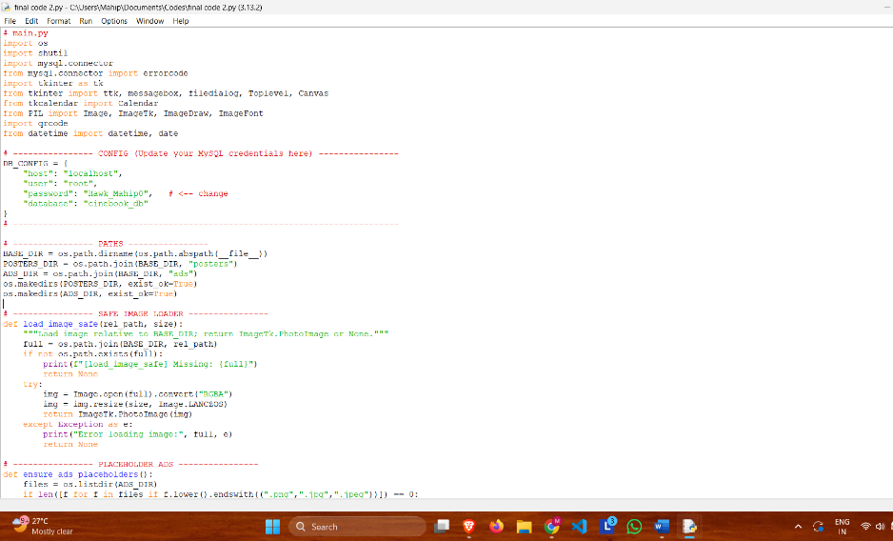

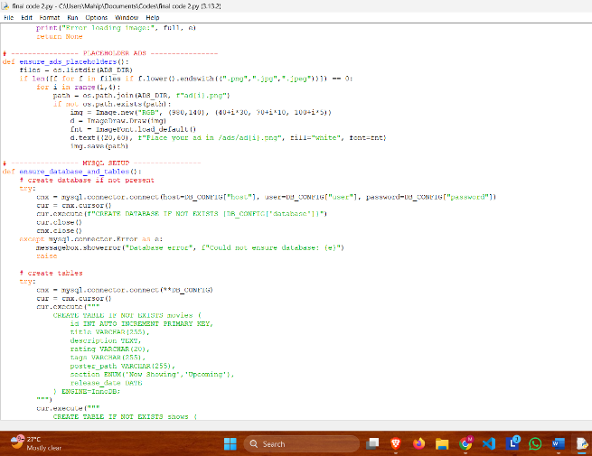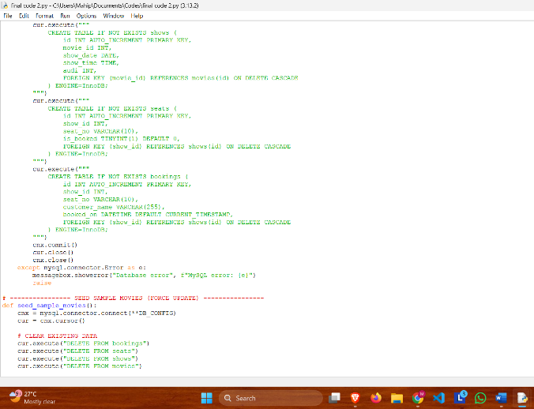

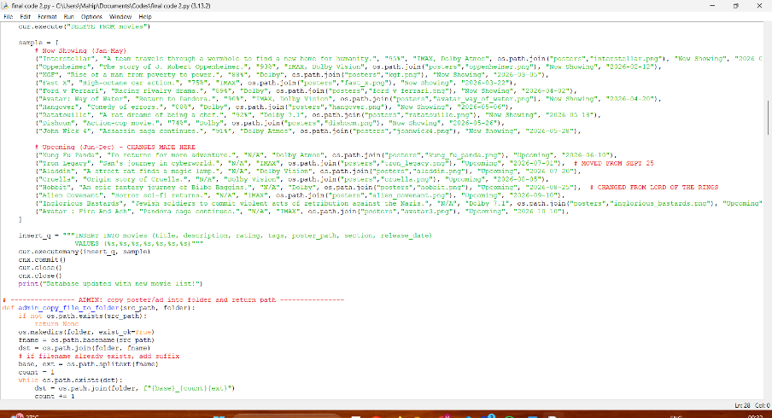

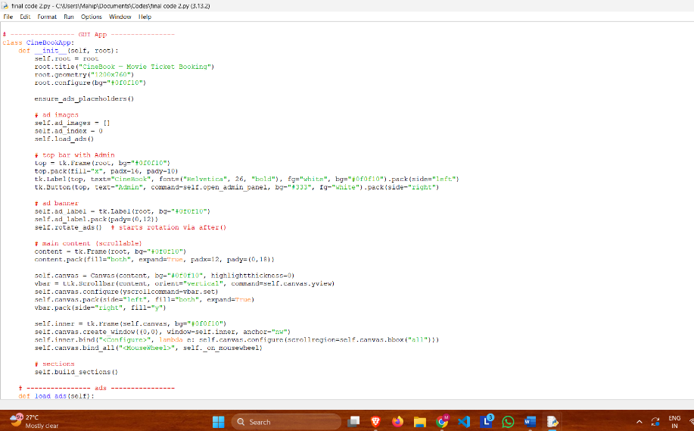

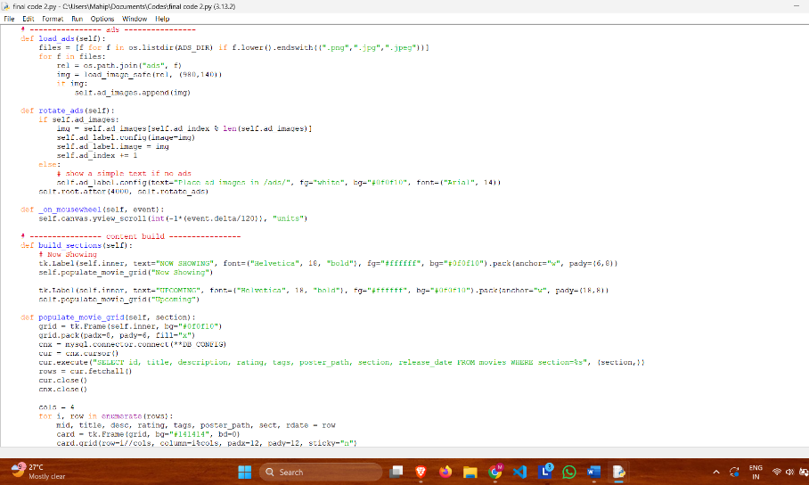

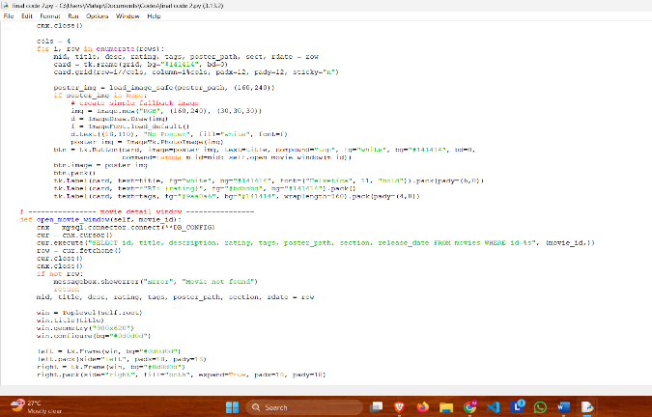

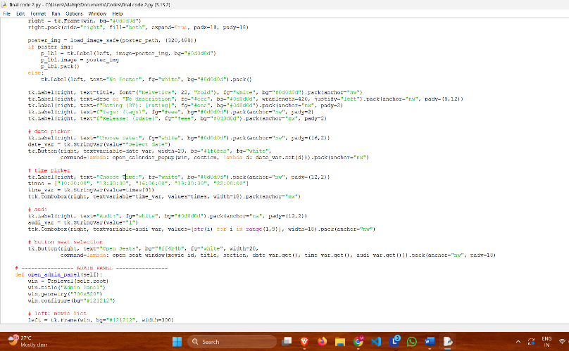

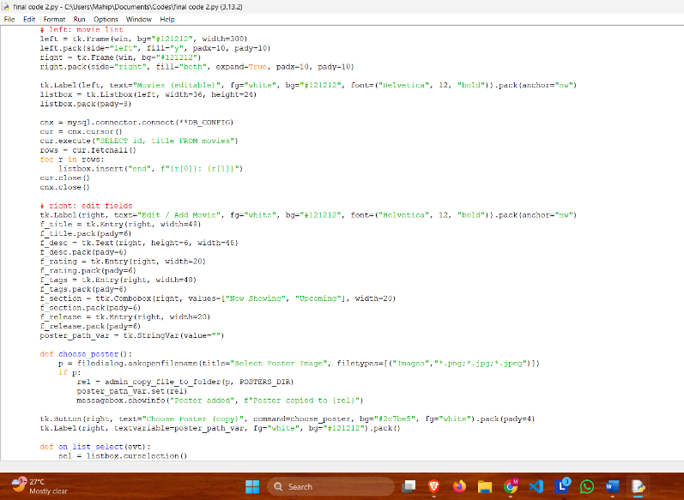

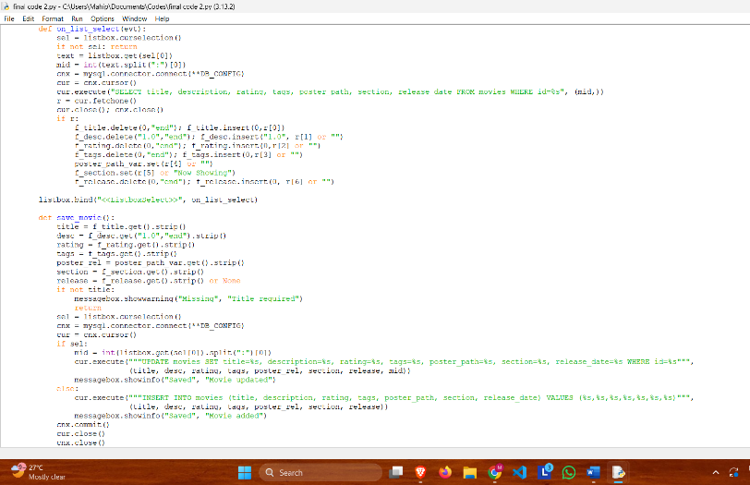

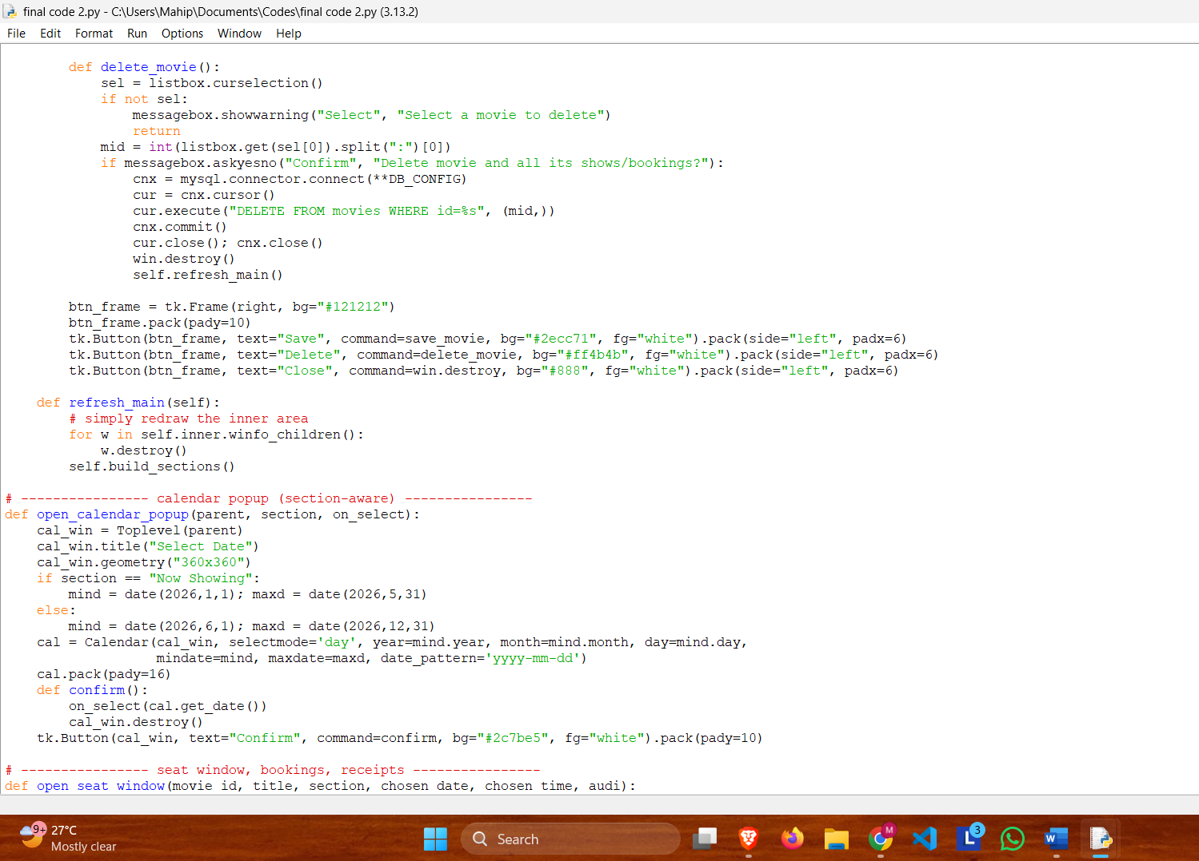

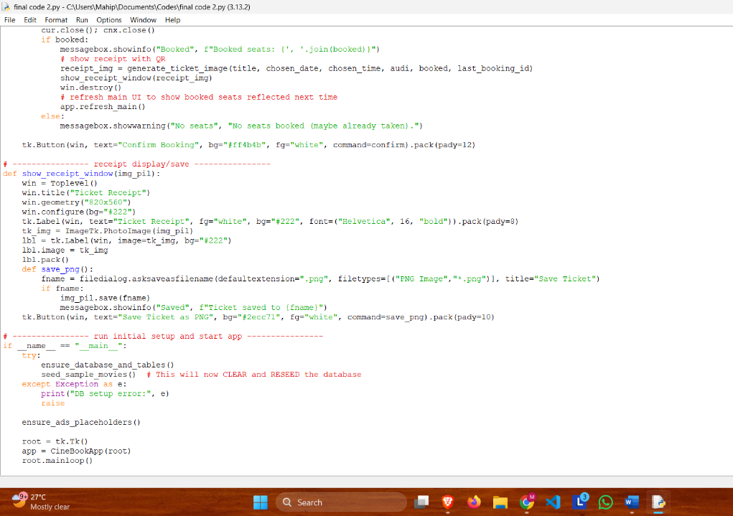

**MYSQL DATABASE**

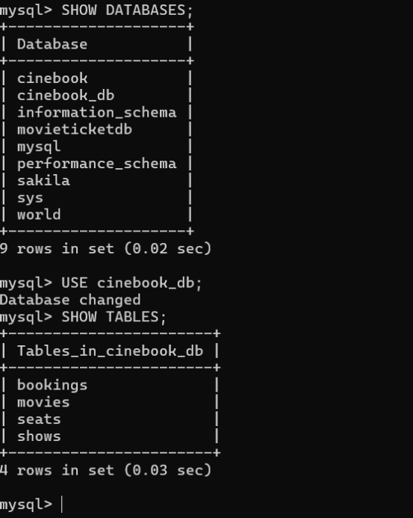 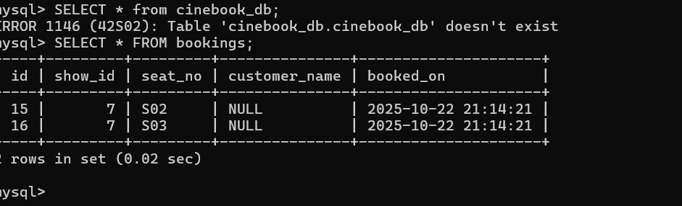

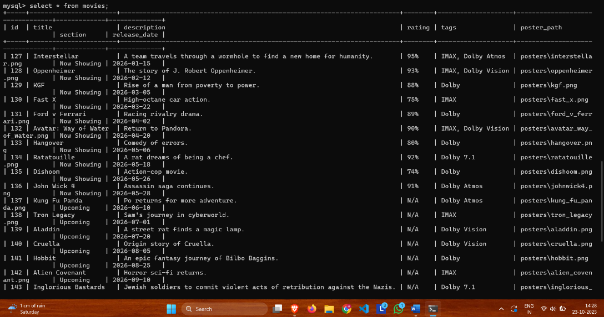

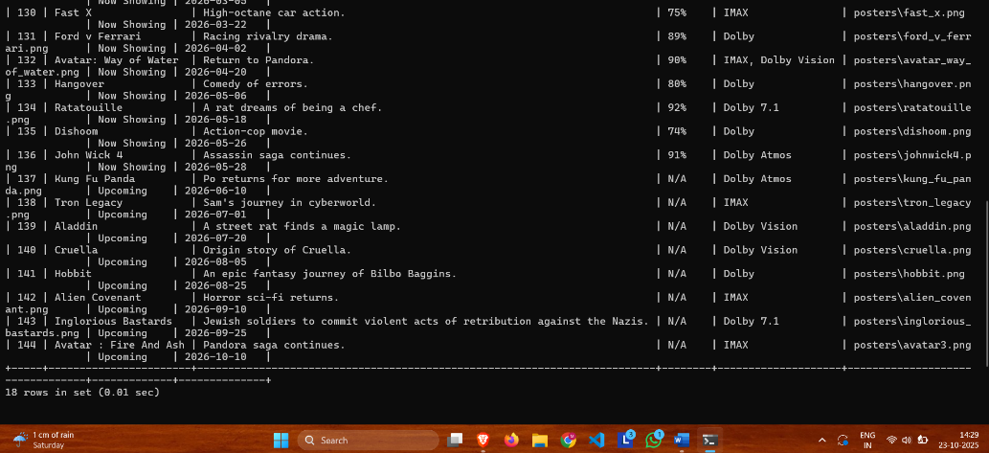

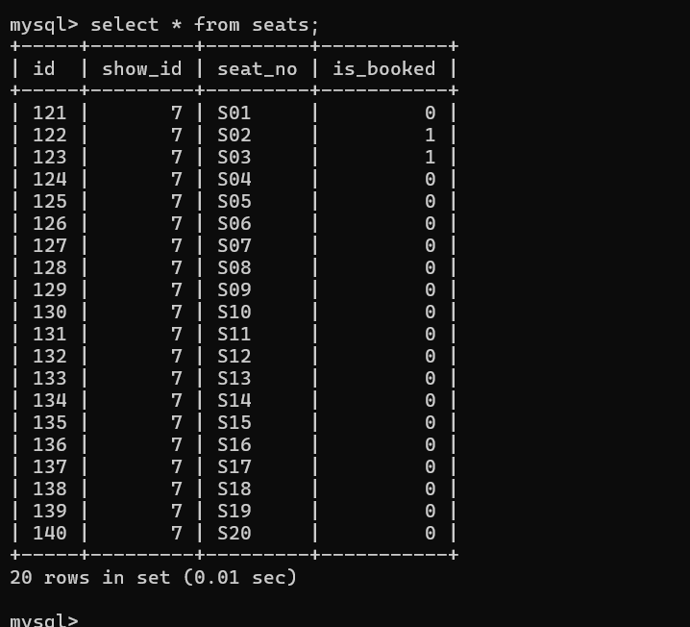

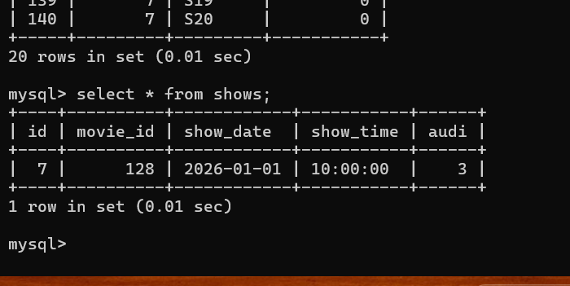

OUTPUT

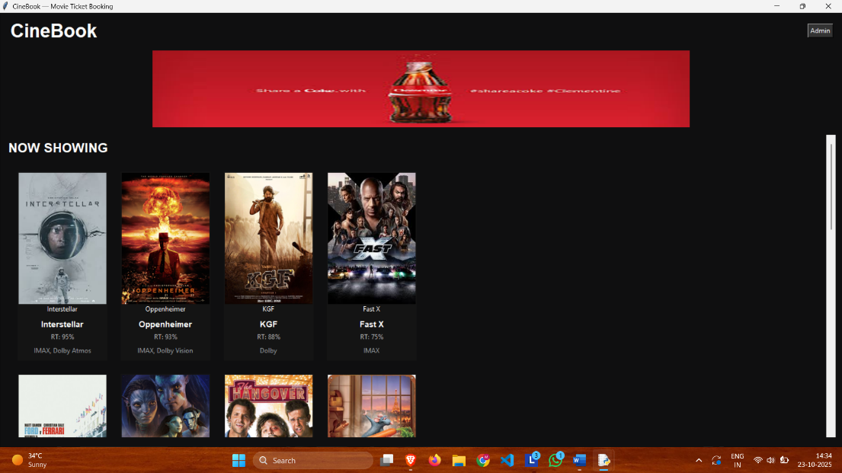

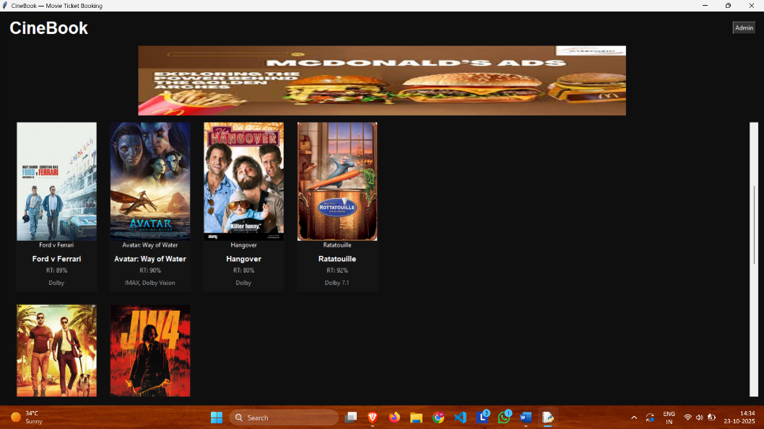

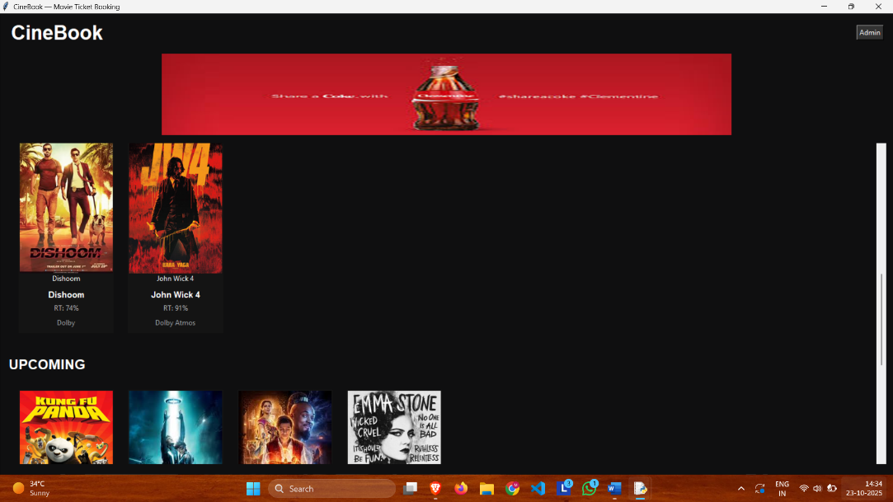

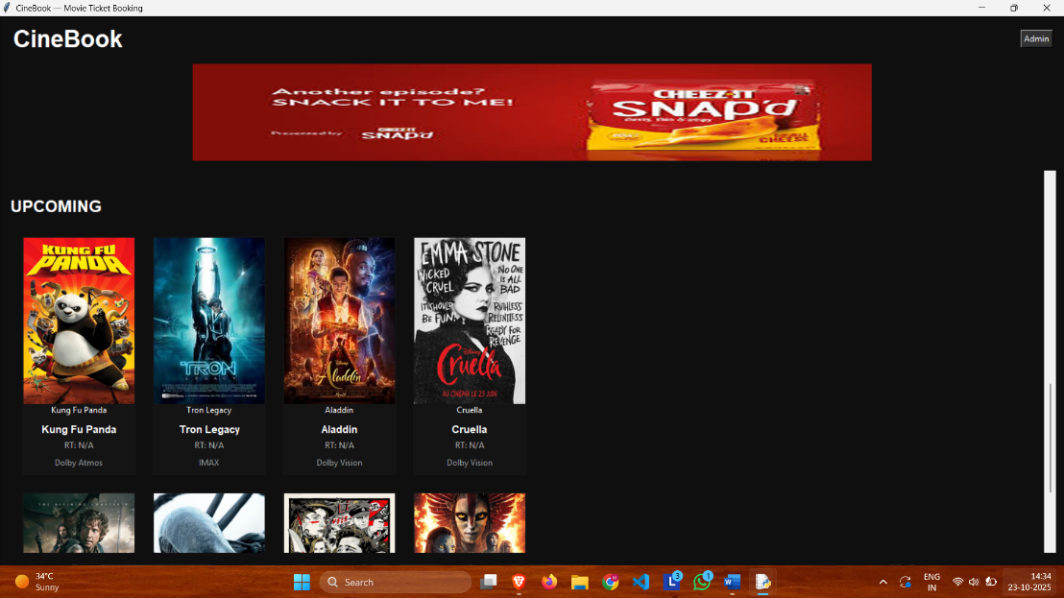

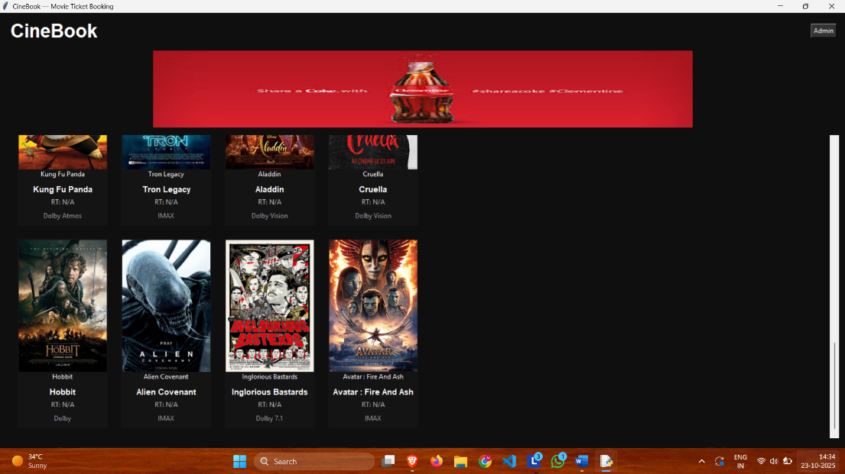

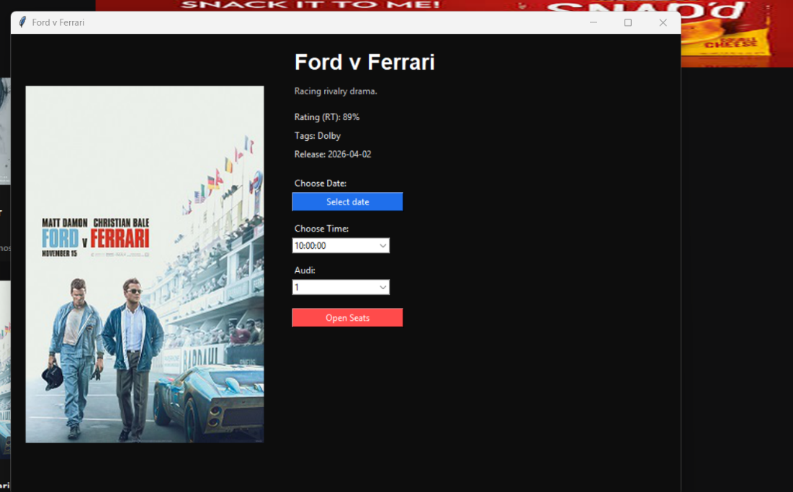

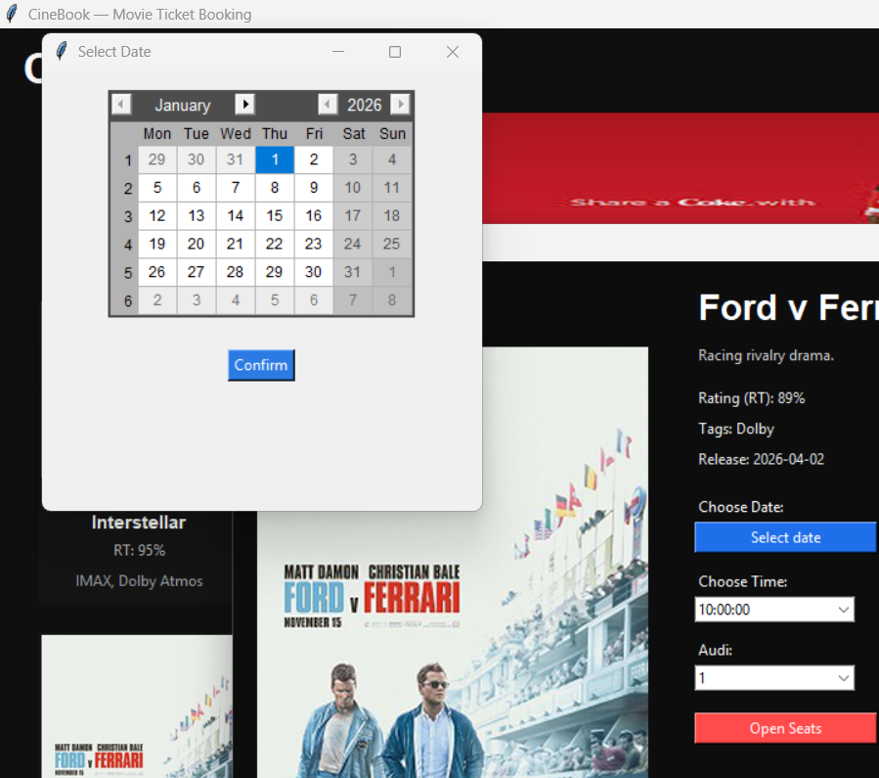

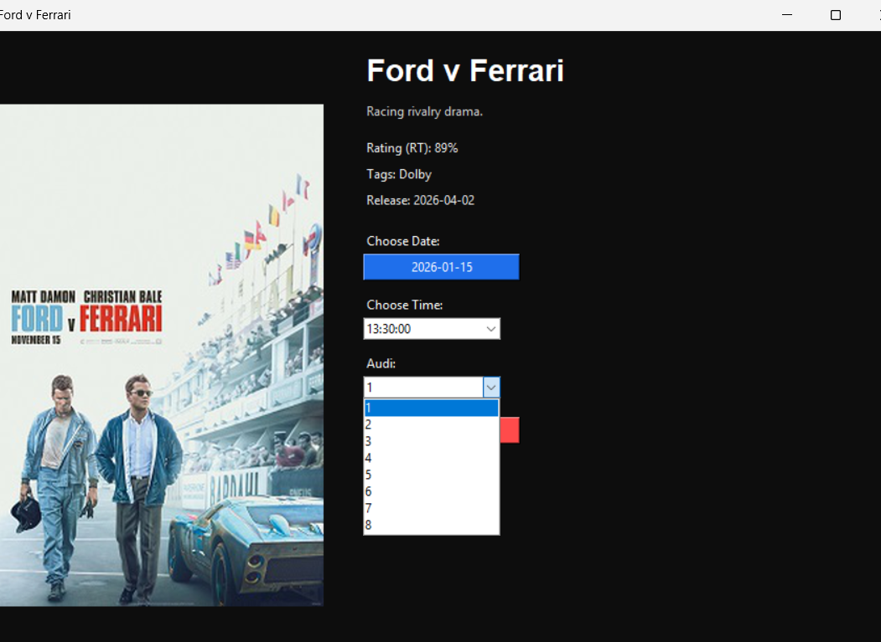

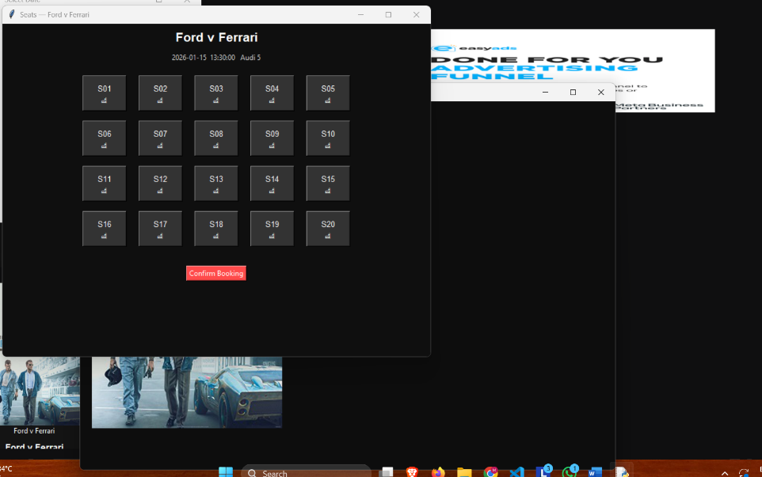

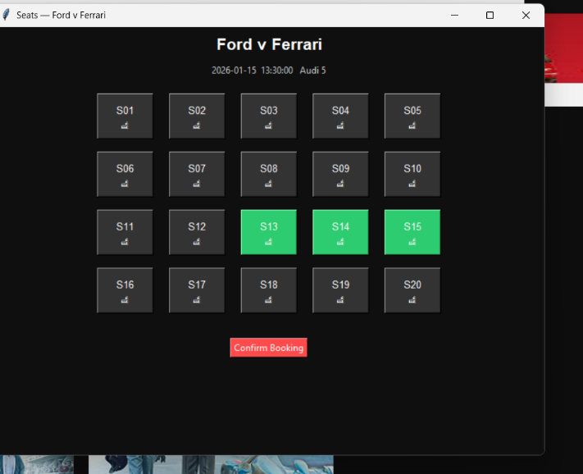

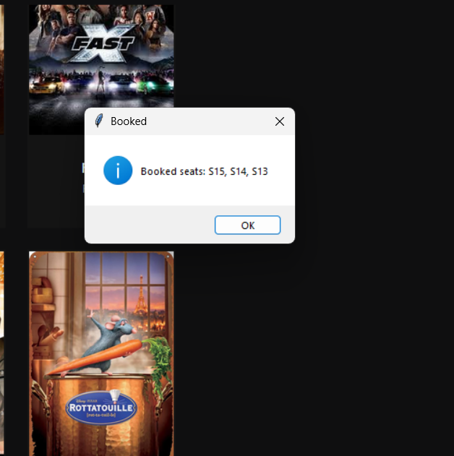

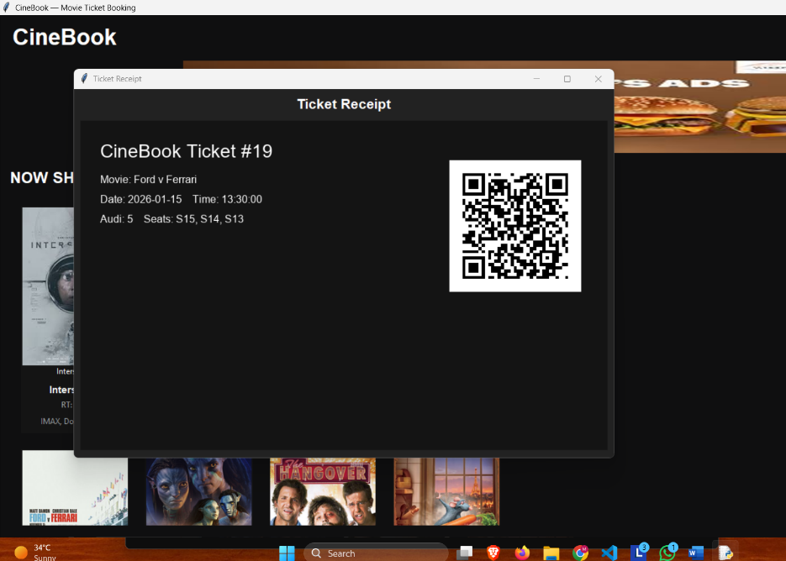

BIBLIOGRAPHY

* 1. GeeksForGeeks
  2. LeetCode
  3. The Big Book of Small Projects
  4. Python Crash Course: Handbook